# File permissions in Linux

## Project description

In this project I will check file permissions, change file permissions, change directory permissions, and view hidden files,

## Check file and directory details

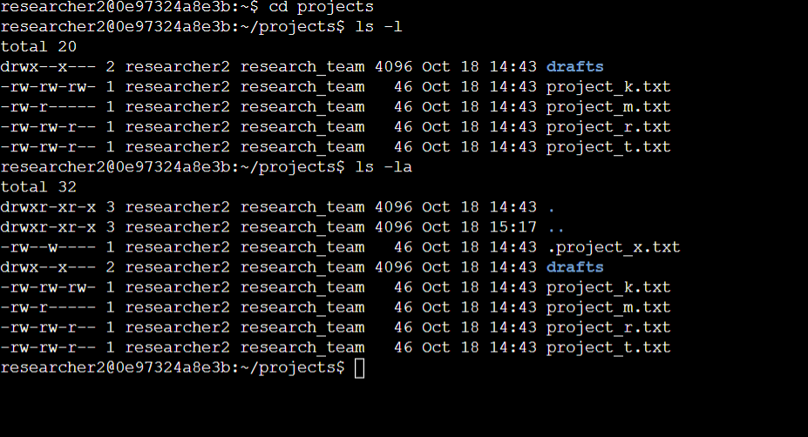

## Describe the permissions string

1. d= directory
2. r= read (users groups or others can read files or directories)
3. w= write (users groups or others can modify files or directories)
4. x=execute (executable files)

d rwx rwx rwx

1. Cluster one or the d Is directory
2. Cluster two is for the user perms
3. Cluster three is for the group perms
4. Cluster four is for the “other” users perms

## Change file permissions

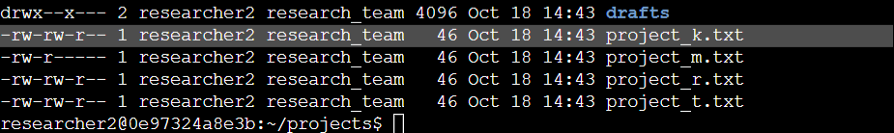

File project_k.txt “other users” no longer has w permissions. This was achieved through the chmod command.

## Change file permissions on a hidden file

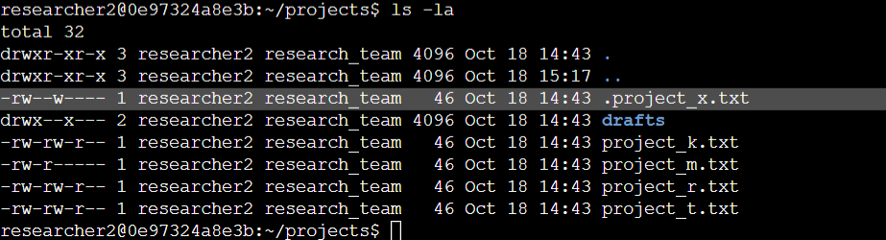

The highlighted portion is a hidden file uncovered via the ls -la command.

I will remove the groups write permissions.

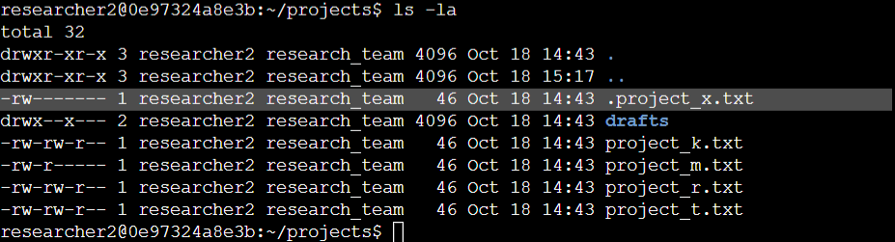

The highlighted portion is shows the write permission have been removed from the hidden files group users using the chmod command.

## Change directory permissions

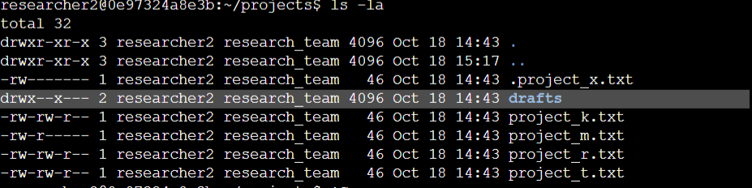

The highlighted portion are the directory permissions “drafts”

I will be removing the executable perms for the group users

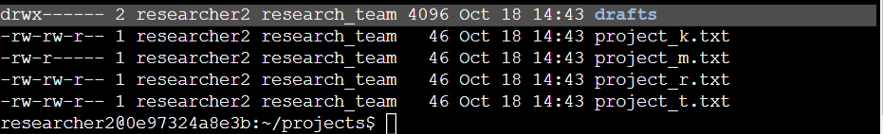

The directory’s group users no longer have execute perms

## Summary

In the following project I have shown I am capable of managing file permissions in Linux Bash. I have demonstrated an understanding of the permissions string, uncovering hidden files, and changing permissions of directories and files.